
Koneru Lakshmaiah Education Foundation
(Deemed to be University estd. u/s. 3 of the UGC Act, 1956)
Off-Campus: Bachupally-Gandimaisamma Road, Bowrampet, Hyderabad, Telangana - 500 043. Phone No: 7815926816, www.klh.edu.in

STUDENT CASE STUDY EXECUTION REPORT
Department | FED
Sub'ect | DSA-2
Academic Year | 1-III Semester | 2025-26
Facult Name | Mohd.Razia
Student Name | U.Shiva Reddy
Roll Number | 2520090172
Branch | CSIT
Course Outcome | CO-3
Case Study Topic: Tournament Venue Connectivity using Kruskal's Minimum Spanning Tree
Work Done Summary:
The SportsAnalytics system manages multiple tournament venues. To establish communication between stadiums with minimum network installation cost, Kruskal's Algorithm is used to construct a Minimum Spanning Tree (MST).
Implementation Details:
- Represent stadiums as graph vertices.
- Represent cable installation costs as weighted edges.
- Sort edges by weight.
- Apply Kruskal's Algorithm.
- Select minimum-cost edges while avoiding cycles.
- Generate Minimum Spanning Tree.

Result: Screenshots / Output
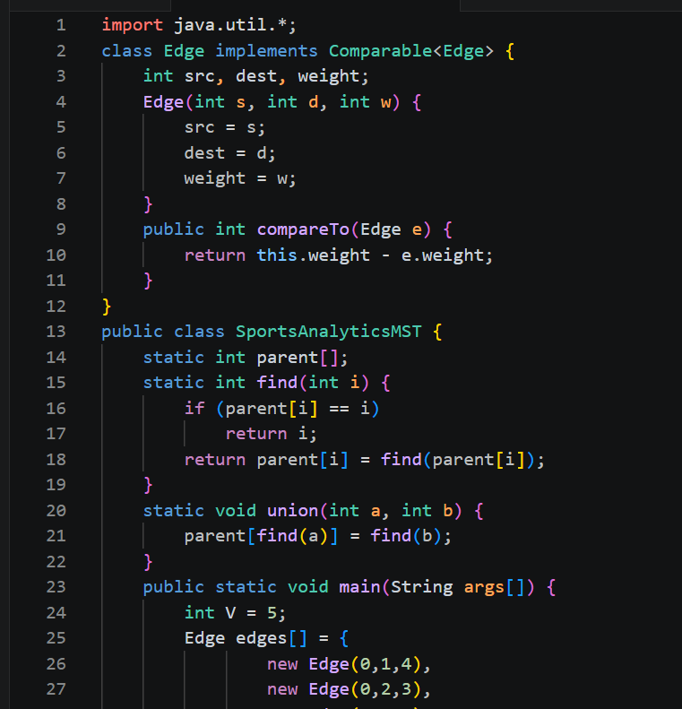
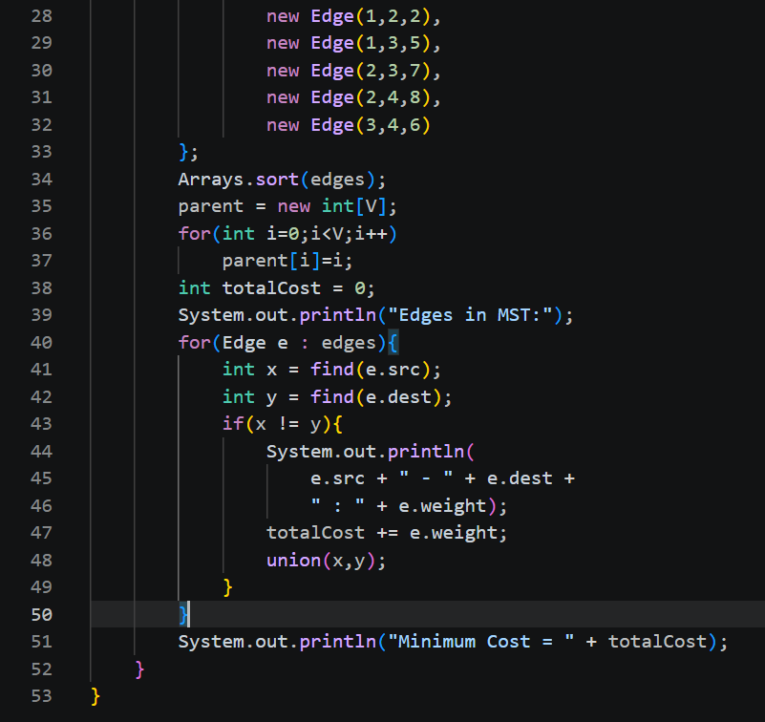

Kruskal's Algorithm successfully connected all tournament venues with the minimum possible network installation cost, making communication efficient and economical.
GitHub Link: https: https://github.com/Shiva77661/SportsAnalytics-Athlete-Performance-Tournament-Management-System/blob/main/import%20java.util.%3B.txt
Student Signature Faculty Signature

